Niger

## Freedom House political status

The data set shows the Freedom House political scores and status of the country each year.

## # A tibble: 19 x 5  
## country iso3c date mean status   
## <chr> <chr> <dbl> <dbl> <chr>   
## 1 Niger NER 1996 6 Not Free   
## 2 Niger NER 1998 6 Not Free   
## 3 Niger NER 2000 4 Partly Free  
## 4 Niger NER 2002 4 Partly Free  
## 5 Niger NER 2003 4 Partly Free  
## 6 Niger NER 2004 3 Partly Free  
## 7 Niger NER 2005 3 Partly Free  
## 8 Niger NER 2006 3 Partly Free  
## 9 Niger NER 2007 3.5 Partly Free  
## 10 Niger NER 2008 3.5 Partly Free  
## 11 Niger NER 2009 4.5 Partly Free  
## 12 Niger NER 2010 4.5 Partly Free  
## 13 Niger NER 2011 3.5 Partly Free  
## 14 Niger NER 2012 3.5 Partly Free  
## 15 Niger NER 2013 3.5 Partly Free  
## 16 Niger NER 2014 3.5 Partly Free  
## 17 Niger NER 2015 3.5 Partly Free  
## 18 Niger NER 2016 4 Partly Free  
## 19 Niger NER 2017 4 Partly Free

## Freedom House classification of political change

The data set shows the GDP growth and the ecomic growth classification of the country each year.

## # A tibble: 19 x 4  
## country iso3c date politicalChangeFH  
## <chr> <chr> <dbl> <chr>   
## 1 Niger NER 1996 no change   
## 2 Niger NER 1998 no change   
## 3 Niger NER 2000 democratization   
## 4 Niger NER 2002 no change   
## 5 Niger NER 2003 no change   
## 6 Niger NER 2004 democratization   
## 7 Niger NER 2005 no change   
## 8 Niger NER 2006 no change   
## 9 Niger NER 2007 autocratization   
## 10 Niger NER 2008 no change   
## 11 Niger NER 2009 autocratization   
## 12 Niger NER 2010 no change   
## 13 Niger NER 2011 democratization   
## 14 Niger NER 2012 no change   
## 15 Niger NER 2013 no change   
## 16 Niger NER 2014 no change   
## 17 Niger NER 2015 no change   
## 18 Niger NER 2016 autocratization   
## 19 Niger NER 2017 no change

## Freedom House score trend

The plot shows the Freedom House scores trend of the country.

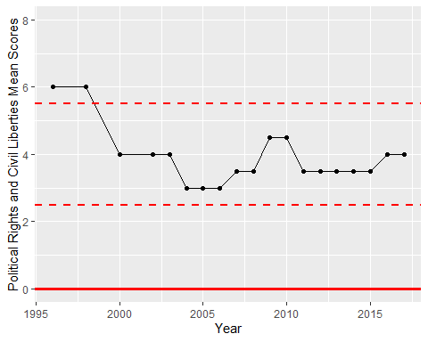

Freedom House Score Trend